COMMONWELTH OF MASSACHUSETTS
DEPARTMENT OF THE TRIAL COURT

Worcester, SS | Worcester Superior Court  Civil Action No.: WOCV2008-0227

Stephen Cleary and Elizabeth Cleary ,  Plaintiff  vs.  Michael Bombard ,  Defendant | )  )  )  )  )  )  )  )  )  )  )  ) | KEEPER OF RECORDS  NOTICE OF TAKING DEPOSITION

TO: | James Horan, Esquire  Gould & Ettenbert, P.C.  370 Main St  Worcester, MA 01608 | James Horan, Esquire  Gould & Ettenbert, P.C.  370 Main St  Worcester, MA 01608

Please take notice that commencing at 10:00 a.m. on at Masi & Bruno, 124 Long Pond Road Unit 11, Plymouth, MA 02360 the Defendant in this action by its attorney will take the deposition upon oral examination of the KEEPER OF RECORDS, Saint Vincent Hospital at Worcester Medical Center , Medical Records, 123 Summer Street, , Worcester, MA 01602 pursuant to Rule 30 of the Massachusetts Rules of Civil Procedure before a Notary Public, in and for the Commonwealth of Massachusetts, or before some other officer authorized by law to administer oaths. The oral examination will continue from day to day until completed. You are invited to attend and cross-examine.

And, you are required to bring with you: Please see attached Schedule A. Please note that if certified records are mailed to and received by Axiom Requisition Copy Service, 447 North Canal Road, Lansing, MI 48917, prior to the deposition date, no one needs to attend the deposition.

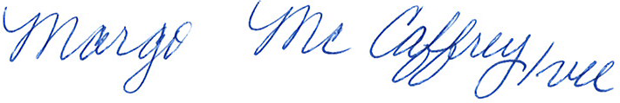
_______________________________________
Margo H. McCaffrey, Esquire
Masi & Bruno
124 Long Pond Road Unit 11
Plymouth, MA 02360
Tel.: (508) 855-4553
Dated:

Order No. 01-18073-001

